

Online Store (BELANJA YUK)

Group (7)

Names : Muhamad Dani Setiawan

Natasha Syeikinah Marsauli

Hudallil Muthaqin

Class : 2Sc8

CEP CCIT

FAKULTAS TEKNIK UNIVERSITAS INDONESIA

2019

**Developed by**

1. **Muhamd Dani Setiawan**
2. **Natasha Syeikinah Marsauli**
3. **Hudallil Muthaqin**



**PROJECT ON**

*Online Store (BELANJA YUK)*

**Online Store (BELANJA YUK)**

Batch Code : 2Sc8

Start Date : June 17, 2019   
End Date : June 30, 2019

Name of Faculty : Listyo Edi Prabowo.ST

Names of Developer :

1. Muhamad Dani Setiawan
2. Natasha Syeikinah Marsauli
3. Hudallil Muthaqin

Date of Submission: June 30, 2019

**CERTIFICATE**

This is to certify that this report titled “Online Store (BELANJA YUK)” embodies the original work done by Muhamad Dani Setiawan , Natasha syeikinah Marsauli and Hudallil Muthaqin. Project in partial fulfillment of their course requirement at NIIT.

Coordinator:

Listyo Edi Prabowo.ST



**ACKNOWLEDGEMENT**

With the name of God, The Most Gracious Most Merciful, we a praise over his presence, which has been part of his grace, so that project about network system can be completed which God willing useful for all of us.

Project report has been in rows with its fullest and got help from various parties and the source so that it can facilitate the creation of this report. And especially to Mr. Listyo Edi Prabowo.ST . Who has provided guidance in making these Project report.

**SYSTEM ANALYSIS**

System Summary:

First, user will enter the website's home page, then the user must create an account if they don't have an account. if they already have an account then they should enter the login menu, after the user enter data and have an account, they can see list of products and choose the product, if the user has found the desired product the user can see the product details and then if the user chooses to buy it then they go to the payment method’s menu

**HTML PAGES**

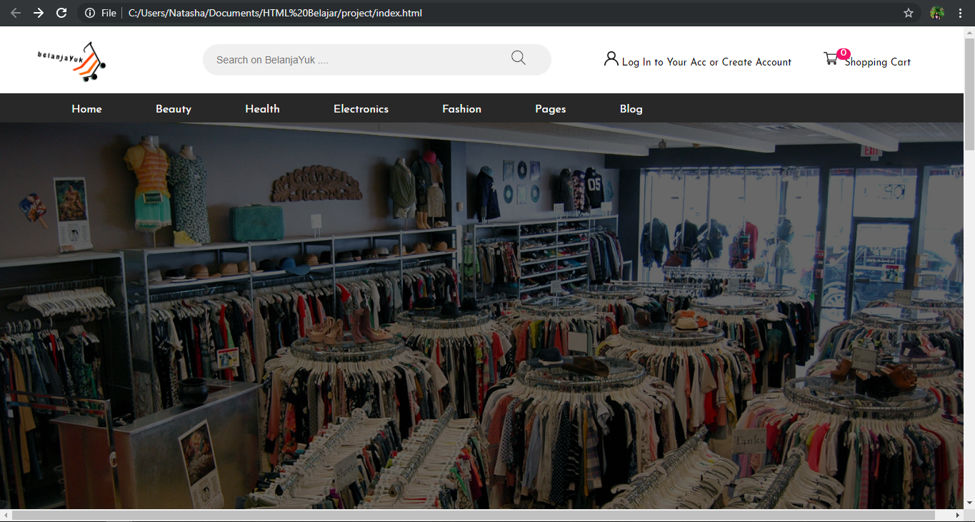

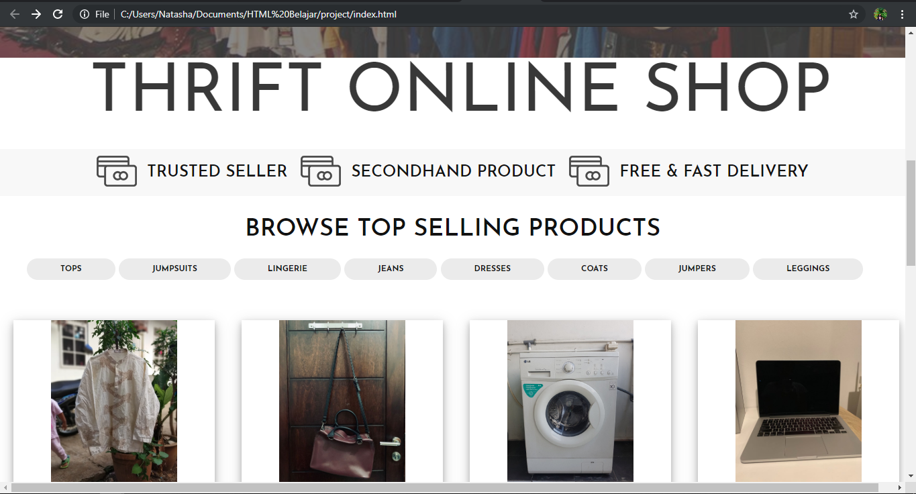

**HTML PAGES**

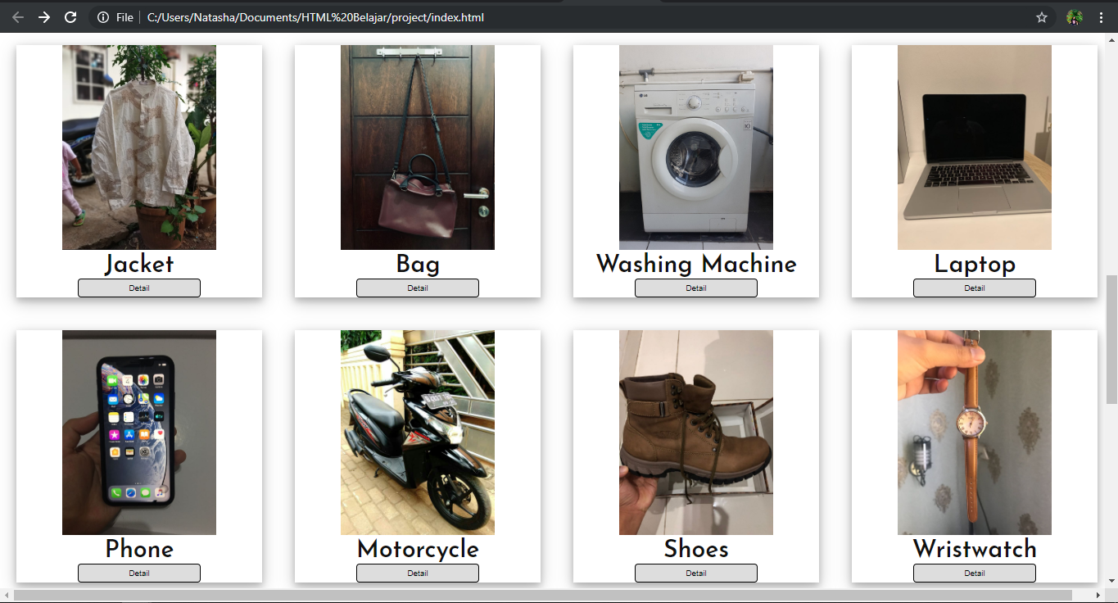

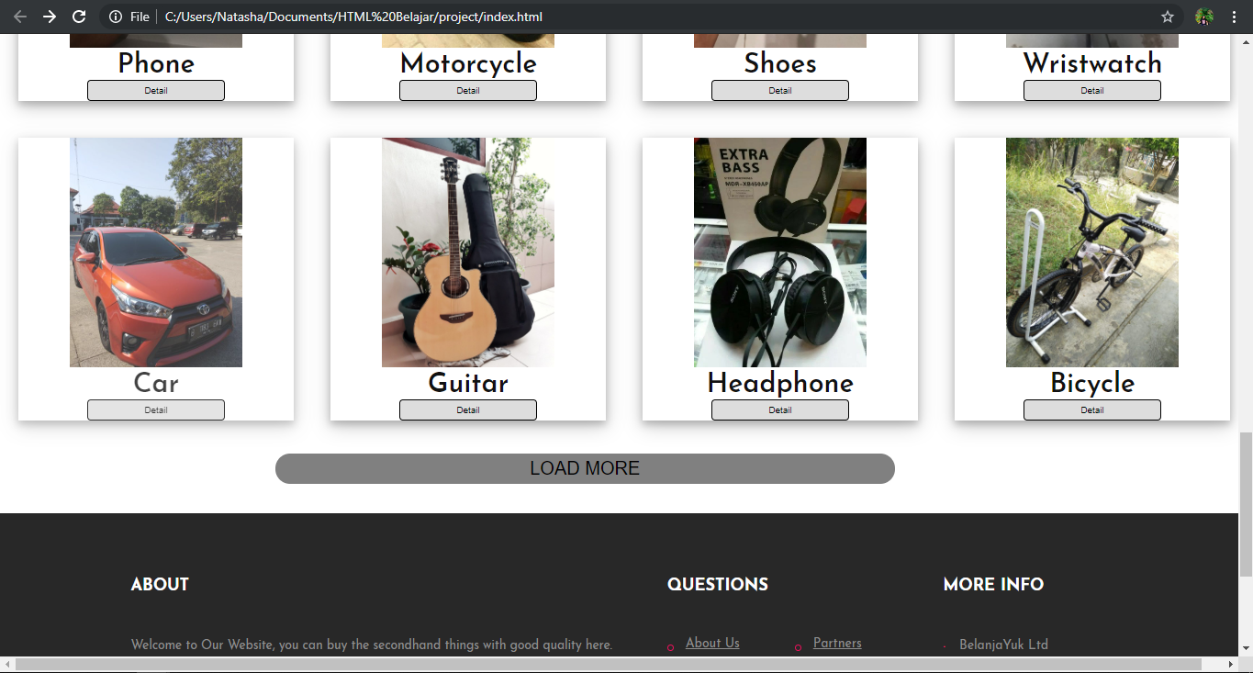

**HTML PAGES**

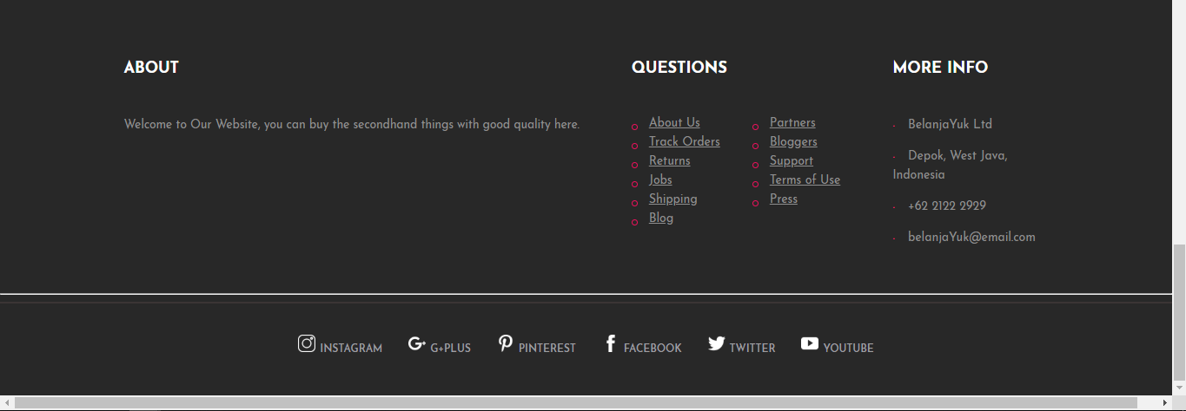

**HTML PAGES**

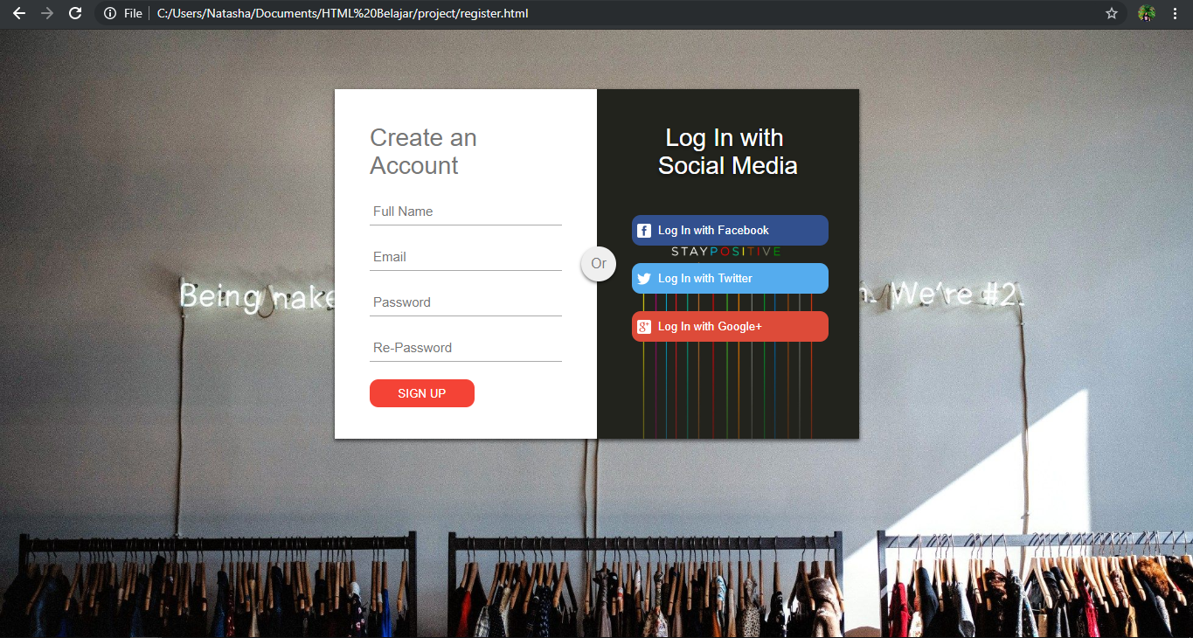

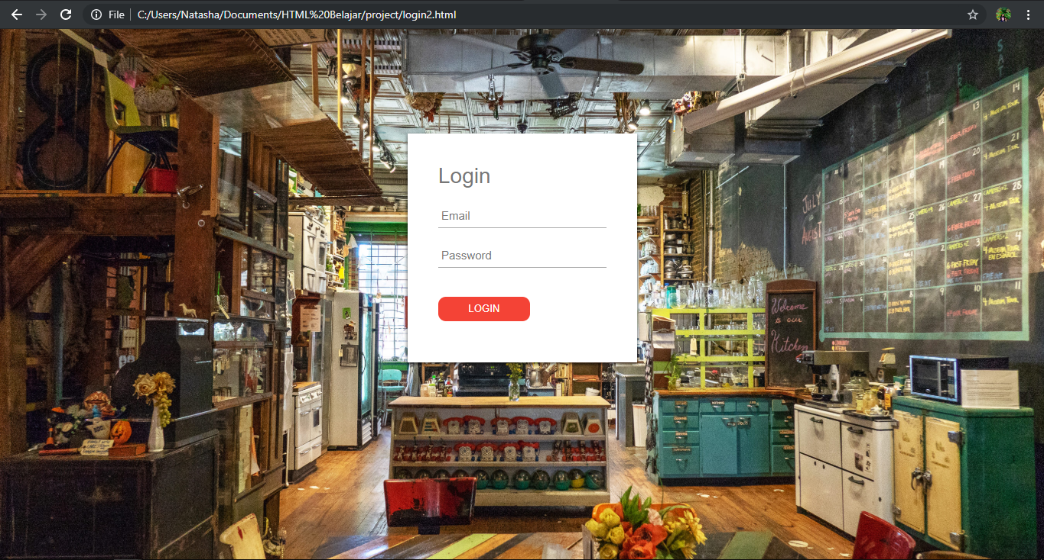

**HTML PAGES**



**HTML PAGES**

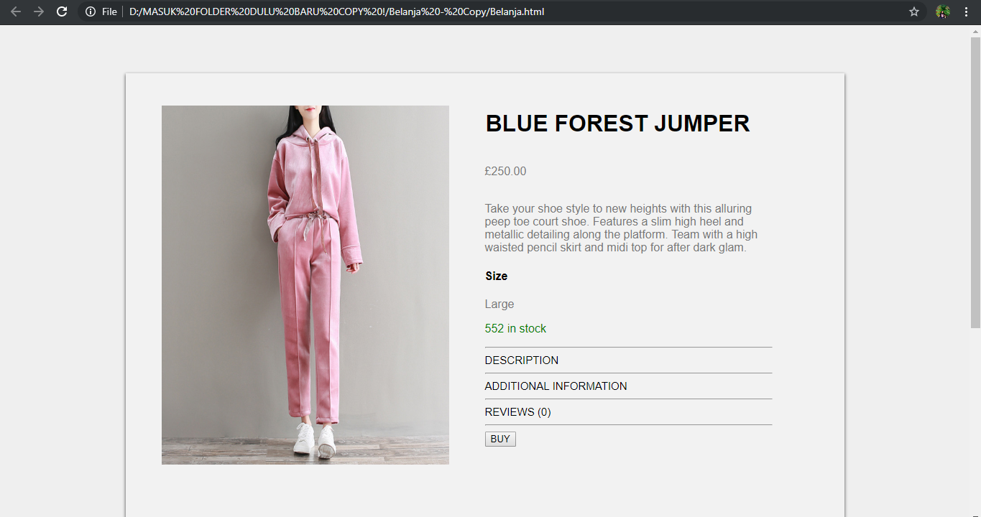

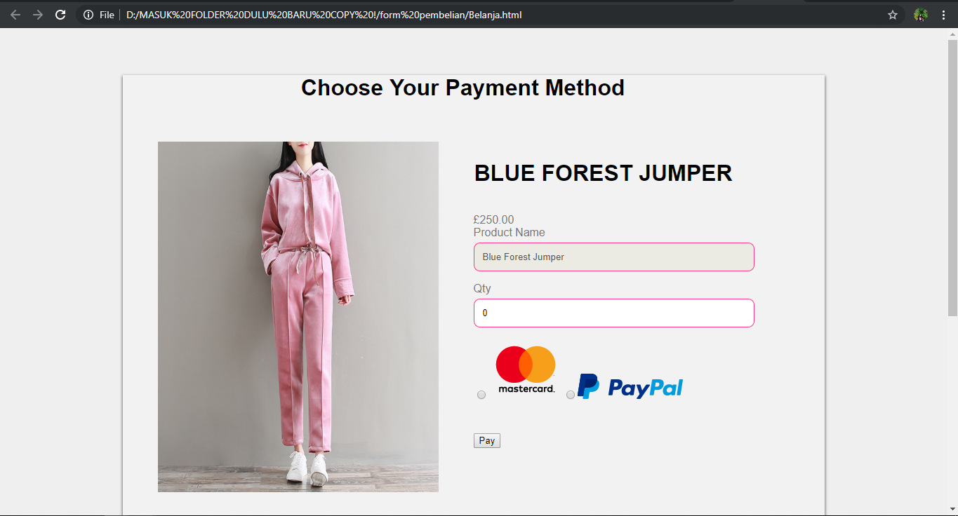

**CONFIGURATION**

**Hardware : Laptop Dell Inspiron 14 7000**

**Operating System : windows 10**

**Software :**  Sublime Text3

|  |  |  |
| --- | --- | --- |
| **PROJECT FILE DETAILS** | | |
| **S.No** | **File Name** | **Remarks** |
| 1 | Index.html |  |
| 2 | Detail.html |  |
| 3 | Payment.html |  |
| 4 | Login.html |  |
| 5 | Style.css |  |
| 6 | Login-Register.css |  |
| 7 | Cekproduk.css |  |
| 8 | Cekproduk.js |  |
| 9 | Login-Register.js |  |
| 10 | Script.js |  |